6/28/2021

RE: NY WORKERS COMPENSATION DIRECT DEPOSIT

Pursuant to 12 NYCRR 300.26, if you are entitled to workers’ compensation indemnity or death benefit payments, you may elect to receive those payments via direct deposit or by paper check in the mail.

Should you elect to receive payments via direct deposit, beginning July 1, 2021, you have the right to have such payments deposited into at least two bank accounts at your request. These payments may either be a percentage of the total benefit or a fixed amount for each deposit, with no required minimum amount.

You have the right to enroll in, change, or cancel the direct deposit at any time by submitting form DD-1 to the claim administrator at Markel Service, Inc., PO Box 3188, Omaha, NE 68103. Cancellation requests will be implemented within forty-five (45) days of receipt of notice, and thereafter payment of benefits will be sent by paper check.

As an alternative to the form DD-1 used for enrollment, Markel also utilizes Western Union for direct deposits (ACH). This process will provide faster setup of your direct deposit as well as additional security for your banking details while allowing you to easily manage your personal information at your convenience. You will also have the option to add your email address so a receipt can automatically be sent to you once your payment has been deposited into your account!

By enrolling online through Western Union, you are agreeing to the following authorizations and understandings:
- I authorize Markel Service, Inc. to directly deposit my workers' compensation indemnity benefits or death benefits into the specified bank account(s).
- I authorize Markel Service, Inc. to debit the account in order to recover any credits deposited in error. Markel Service, Inc. may recover credits deposited in error by any lawful means. IMPORTANT: This consent does not authorize Markel Service, Inc. to recover alleged over payments of established and awarded benefits.
- I understand that any change in my employment status may affect my right to receive benefits.
- I understand that any false statement or failure to disclose a material fact in order to obtain or increase my benefits may result in criminal prosecution, disqualification from benefits, and repayment of any funds deposited to my account.
- I understand that the failure to notify Markel Service, Inc. of any change in financial institution or account may delay receipt of my benefits or settlement proceeds.
- I understand that in order to change or cancel the direct deposit for my workers' compensation indemnity benefits or death benefits, I need to submit a written request to Markel Service, Inc. at PO Box 3188, Omaha, NE 68103.
  - I understand that I have an obligation to immediately notify the claim administrator if I am no longer entitled to such payments, or of changes in circumstances which affect my entitlement to such payment.
  - I understand that the claim administrator may require me to certify annually that I continue to elect the receipt of such benefits by direct deposit, and that if I fail to do so, the claim administrator may discontinue direct deposit and thereafter provide benefits by paper check

Enrollment:
To complete the Western Union ACH enrollment form, please click the link provided below… It’s that easy!

https://payee.globalpay.westernunion.com/PayeeManager/BeneficiaryEnrollment/SpecifyPayeeID.aspx?id=0C08F61C42D298C59F579E5D1671B408

Quick Tips for online enrollment:

- Payee ID – Will be assigned in our claims system automatically, there is no need to enter information
- Company Name – Should be the first and last name of the payee (this allows us to locate your account if you require future assistance)
- Country – US (majority of the time)
- Phone Number – Phone number of the payee
- Tax ID – SSN of payee
- Corporation – Not required, but may provide response of “No” for reporting purposes.

As a part of our ACH payment process, you have the option to split payments between two separate bank accounts, should you wish to do so. You should follow the enclosed instructions to split your benefit payments between two separate bank accounts.

If you may need additional assistance with enrollment, please contact Markel's Epayment Solution Center at 1-800-815-2460 or epay@westernunion.com .

Our Western Union ACH enrollment form is completely online and electronic, which allows you to enroll and submit the form all in one process.
Navigate to: https://payee.globalpay.westernunion.com/PayeeManager/BeneficiaryEnrollment/SpecifyPayeeID.aspx?id=0C08F61C42D298C59F579E5D1671B408

Please leave this field blank during the enrollment process. Markel will assign a Payee ID to you for each bank account:
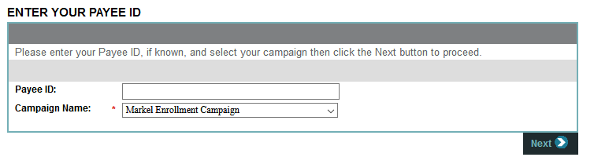

You will enter your personal information on the first page. Instead of the Company Name or Tax ID, you will enter your First and Last Name and SSN:
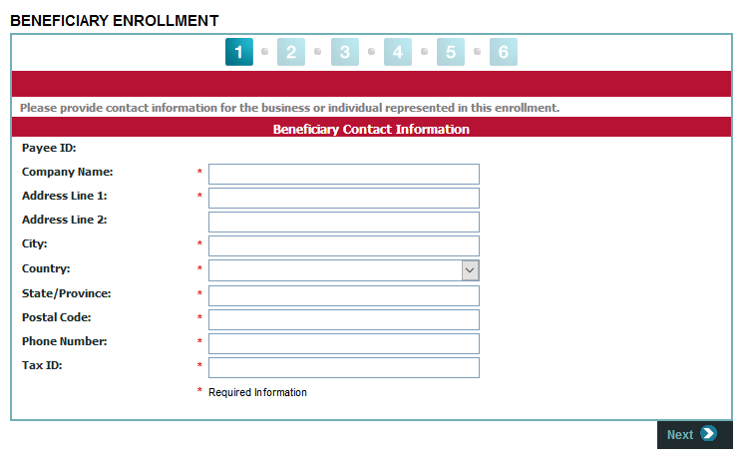

The second page is where you will enter your contact information in the event we need to reach you in regards to your payment:
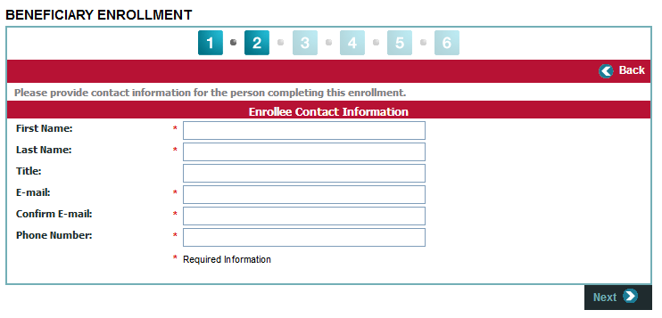
The third page you will create a username and password. This will allow you to see a history of payments as well as manage your bank account that is enrolled for payment:
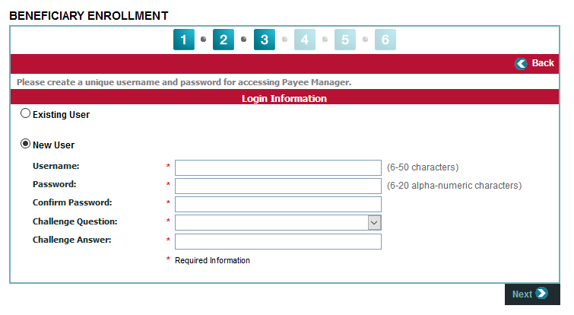

The fourth page is where you will enter your bank details and on page 5 accept the Western Union Service Agreement.
You can use the Find A Bank feature or use Enter Bank Manually.

In the Other Information/Notes section, please enter your WCAB Number (the WCAB number can be obtained from Markel Service, Inc. by contacting customer service or your adjuster).
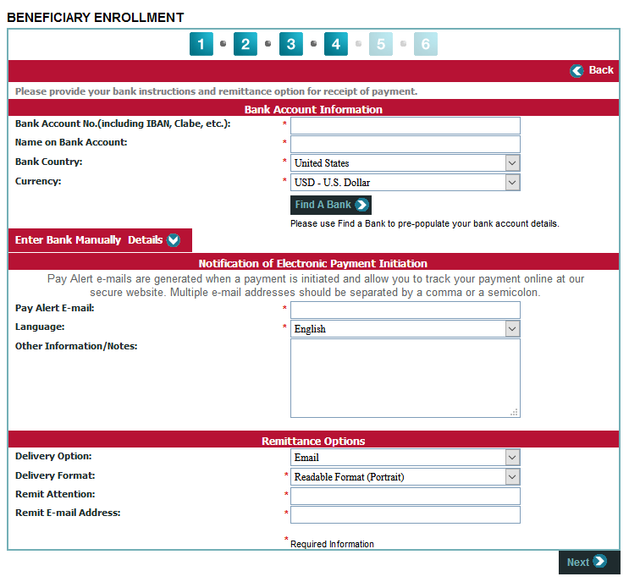
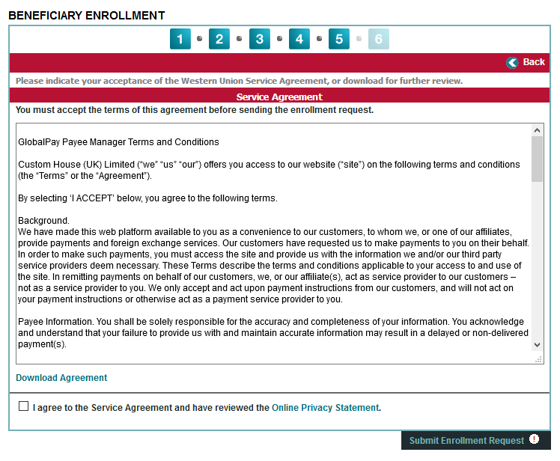

If you want to have your direct deposit split between two accounts you will need to add a second account to the enrollment after it is approved. That can be done with the following instructions.
Log into https://payee.globalpay.westernunion.com/PayeeManager/Beneficiary/Login.aspx with the User ID and Password created during enrollment:
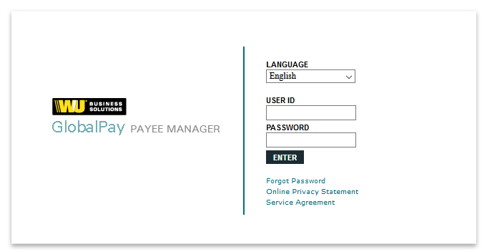

Once you are logged in, you will see Add Bank Account as a link in the Active Bank Accounts section:

Fill out the online form the same as when you entered the first bank account and click on Submit Entry:
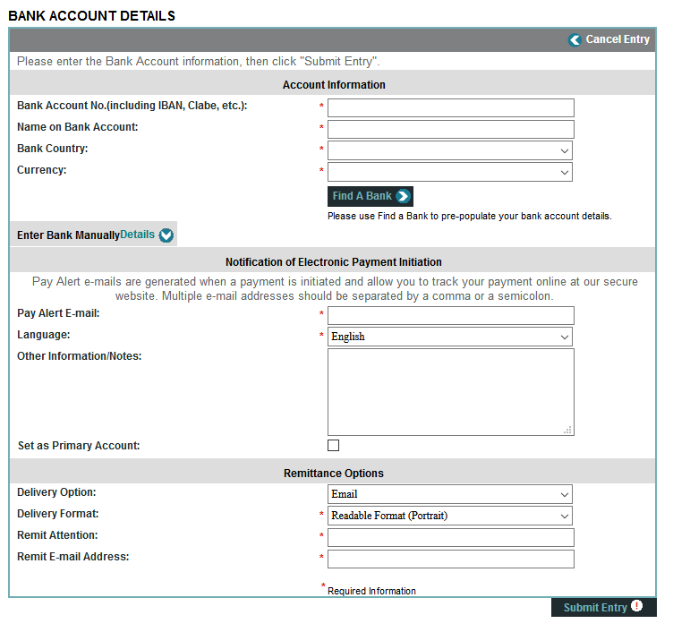

CLAIMANT'S RIGHTS TO DIRECT DEPOSIT

- This form is optional, but you have the right to receive your workers' compensation indemnity benefits or death benefits in the form of direct deposit. You also have the right to receive your workers' compensation indemnity benefits or death benefits by paper check in the mail.

- You have the right to cancel the direct deposit at any time by checking the appropriate box on this form and forwarding the completed form to the claim administrator responsible for the workers' compensation claim. The request will be implemented within forty-five days of receipt of notice, and thereafter payment of benefits will be sent by paper check.

- Beginning July 1, 2021, you have the right to have such payments deposited into at least two bank accounts at your request, either as a percentage of the total benefit or a fixed dollar amount for each deposit. The claim administrator may require a minimum amount of up to $20 into each bank account.

AUTHORIZATIONS & UNDERSTANDINGS

- I authorize the claim administrator to directly deposit my workers' compensation indemnity benefits or death benefits into the specified bank account(s).

- I authorize the claim administrator to debit the account in order to recover any credits deposited in error. The claim administrator may recover credits deposited in error by any lawful means. IMPORTANT: This consent does not authorize the claim administrator to recover alleged over payments of established and awarded benefits.

- I understand that any change in my employment status may affect my right to receive benefits.

- I understand that any false statement or failure to disclose a material fact in order to obtain or increase my benefits may result in criminal prosecution, disqualification from benefits, and repayment of any funds deposited to my account.

- I understand that the failure to notify the insurance carrier, self-insured employer, or third-party administrator (TPA) (claim administrator) of any change in financial institution or account may delay receipt of my benefits or settlement proceeds.

- I understand that in order to change or cancel the direct deposit for my workers' compensation indemnity benefits or death benefits, I need to submit this form to the claim administrator.

  - I understand that I have an obligation to immediately notify the claim administrator if I am no longer entitled to such payments, or of changes in circumstances which affect my entitlement to such payment.

  - I understand that the claim administrator may require me to certify annually that I continue to elect the receipt of such benefits by direct deposit, and that if I fail to do so, the claim administrator may discontinue direct thereafter provide benefits by paper check.

DIRECT DEPOSIT AUTHORIZATION FORM
Do not send to the Workers' Compensation Board.

☐ NEW ENROLLMENT ☐ CHANGE ☐ CANCEL

SECTION 1 (TO BE COMPLETED BY CLAIMANT)
Depositor/Claimant's Name (last, first): | WCB Claim Number:
Phone Number (including area code): | E-mail Address:
Address:
DEPOSITOR/CLAIMANT/JOINT ACCOUNT HOLDER CERTIFICATION
I certify that I am entitled to receive the underlying compensation payments or death benefits and circumstances entitling me to benefits or death benefits have not changed. I understand that the claim administrator may request an annual certification of continued entitlement to such payments or benefits and that such certification must be provided within sixty days in order to continue payments by direct deposit.
Depositor/Claimant Certification Signature | Date
Joint Account Holder Certification Signature | Date

SECTION 2
Please check with your financial institution to complete the requested information in this section. Direct deposit is only available if your financial institution is part of the New York State Automated Clearinghouse. In addition, the depositor's name MUST appear on the account

Name of Financial Institution: | Account Type:  ☐ Checking ☐ Savings Amount or Percentage to be deposited:
Depositor's Account Number (EFT Format): | Routing Number:

Name of Second Financial Institution: | Account Type:  ☐ Checking ☐ Savings Amount or Percentage to be deposited:
Depositor's Account Number (EFT Format): | Routing Number:
DD-1 (5-21)

